Hespeler P.S. School Council Meeting

MINUTES
Monday, April 20, 2026
7:00 pm
Present: Chris Sciascetti, Cheryl Tawse, Julia Passmore, Kristin Lovell, Alicia Young, Sarrah Beemer, Michelle Bush Broga, Sharon McKeown, Kyly Miller, Tara Delaney, Jesse Sabbagh, Marissa Glen, Melissa Legros-Cronkwright, Crystal Bechtel, Rebecca Mills

Regrets: Stacey Lawrence, Jill Bolender, Rachel Bain, Darcie Black

Absent: Fatima De Lange

Chair: Sharon M
Secretary: Chris S
Treasurer: Kyly

- Welcome/Introductions

- Approval of Minutes from March 9, 2026
- Approved as read - Michelle motioned to approve, Kristin seconded, approved unanimously.

- Treasurer’s Report

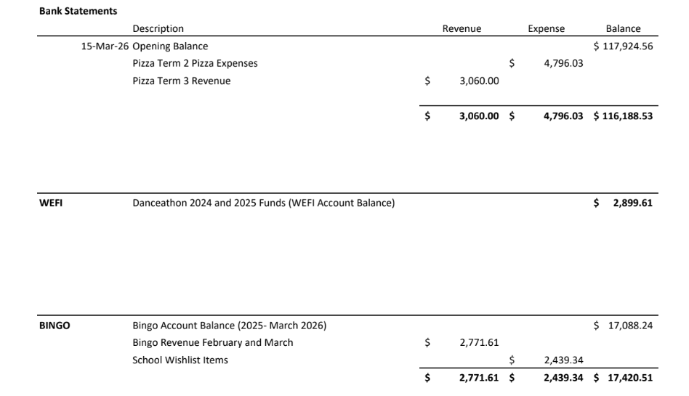

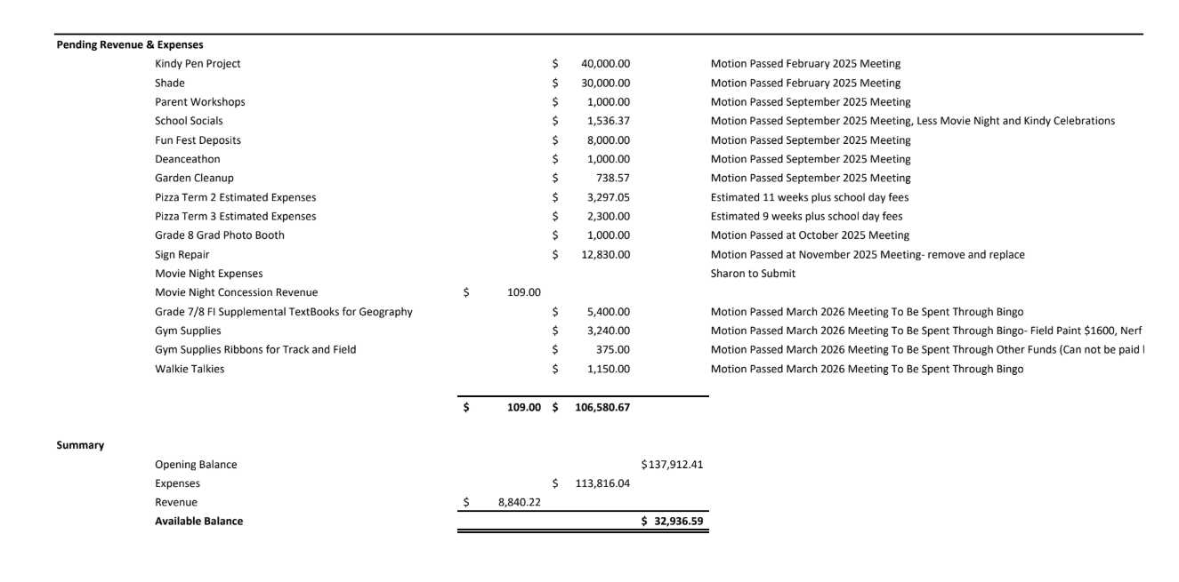

- Michelle Motioned to approve the additional funds spent from the wishlist ($1469.18), Kristin Seconded, All in Favour

- Principal/Vice-Principal Update:

Staffing Update:
- Lori LaRonde starting for James (thank you Cole Newell)
- Jenn Weatherall joined in the library (Tuesdays and Fridays)
PD Day this Friday:
- focus on use of approved AI tools and SLIP Goals - Cognitive Load and creating the Conditions for Learning in Classrooms

Planning for 2026-2027:
- Enrolment down from 615 (now) to 553 (September 2026)
- Down 2 classes (one in junior, one in intermediate)
- Down 3 teachers
- Considering a 4:4:2 Timetable

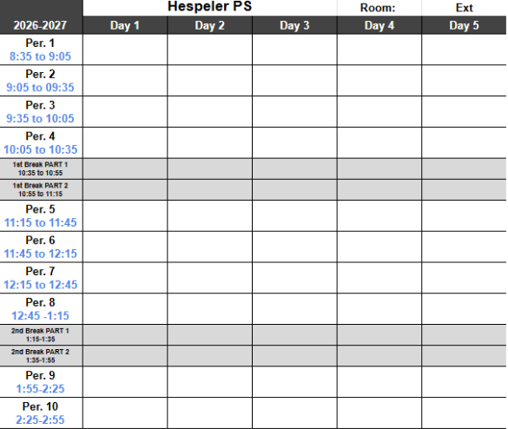

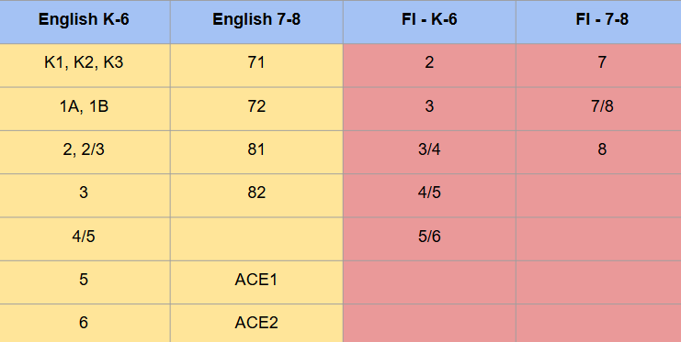

Hespeler Happenings:
- Weekly Pizza (Mondays)& Weekly Popcorn (Thursday)
- Grade 2 and 2/3 classes visit St. Lukes and read/craft with residents continues.
- Dance a Thon was last week! DJ Marshmallow (Mr.Akgol) had the tunes going all day!
- Wrestling Finals took place on Saturday.
- Jump Rope for Heart-April 16-29 in phys ed classes for our K-6 students
- Track and Field is starting (dates on next slide)

Upcoming Dates:
- April 16-20 - Jump Rope for Heart
- April 22 - Earth Day: Wear Green and Blue
- April 24 - PD Day
- April 29 - Gr 7 Immunization
- June 24 - Grade 8 Graduation

EQAO
- Grade 6s: May 25 and 26, Back up day May 27
- Grade 3s: June 2 and 3, Back up day: June 4

TRACK AND FIELD DATES
Grade 7/8
May 5 @ JHSS all day
Rain Date May 7 @ HPS all day
Divisionals
May 26 @ JHSS all day
June 3 rain date @ JHSS all day
Counties
June 4 @ JHSS 4 pm-9pm

Grades 4-6
May 15 @ JHSS
Rain Date May 20 @ HPS

- New Business
- Bingo Update
  - Allocation of funds - process update
  - Google spreadsheet for tracking of counsel approvals and approvals from the gaming center
  - May 19 - need one more volunteer. Jesse to volunteer
  - In the fall, look at inviting parents to volunteer through school day

- Danceathon (Sharon)
  - Thank you to the helpers who supported the event
  - Funds were down this year - economy and a change in how it was announced
  - Online donations report has not been returned, we think we raised approx $6500.00 - waiting on the verification report
  - Pie in the face/assembly/ice cream party date is May 13, 2026

- Other Business
- Sign Update
  - Worked with Area Facilities Manager - need to use a new board vendor. THey will not start work until September but we will be the first school completed in September.

- Kindy Pen/Trees Update
  - Landscaper came last week to provide two quotes, one for moving into the back of the school and one quote to fix it where it is. Waiting for the quote and then it will go out to tender.

- Parent Workshops
  - Look for September Dates for Alison Yeung to come for a parent (Instagram handle: the smart phone effect) , Topic Social Media and Mental Health

- Fun Fest
  - Streamline process to speak to admin staff from council, asked filtered through Sharon (council chair), then to Julia and then to the admin staff
  - Discuss not having the silent auctions items as per the September 2025 minutes, look at some donations for the kiddie prize tables, like the scooters. Motion to have 10 silent auction items (top ten), plus the classroom baskets - motioned Kristin, seconded by Marissa, all in favour
  - Need support to have different classroom baskets, not having the same type of baskets - council has a plan to support variety. Communication after the 2nd week of May.
  - Volunteers are looking lower for volunteers - looking for support
  - Main event is booked - in addition to having the petting zoo, volleyball, soccer, element dance

- Garden
  - Mr.Grimm and his group plus the gardening committee looking for funds, $1500 to support the purchase of soil. Mr. Grimm will not be here next year.
  - Decline request - will revisit when Mr. Grimm returns and proposes it.

Next meeting is May 11, 2026

MEETING ADJOURNED 8:19 PM
Jesse motioned to end the meeting, Tara seconded, all in favor.

Meeting Dates: May 11 (Early to avoid Victoria Day), June 15

